  Introduction of AI :  • Definition: Artificial Intelligence (AI) is the field of computer science that focuses on creating machines capable of simulating human intelligence, such as learning, reasoning, and problem-solving.  • Applications: AI is widely used in everyday life, including virtual assistants (like Seri, Alexa), self-driving cars, healthcare diagnosis, and recommendation systems (like Netflix or YouTube).  • Importance: AI is transforming industries by automating tasks, improving decision-making, and enabling innovative technologies that shape the future of work and society.
  Main Uses of Artificial Intelligence (AI):
  - Healthcare: AI helps in diagnosing diseases, analyzing medical images, and developing personalized treatment plans.
  - Education: Smart tutoring systems, personalized learning, and automated grading.
  - Business: Chabot’s, customer support, fraud detection, and data analytics.
  - Transportation: Self-driving cars, traffic management, and route optimization.
  - Entertainment: Recommendation systems on Netflix, YouTube
  - Security: Facial recognition, threat detection, and cyber security.
  - Daily Life: Virtual assistants like Seri, Alexa, and Google Assistant.
  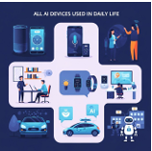
  Types of AI: • Narrow • General • Super Intelligent AI
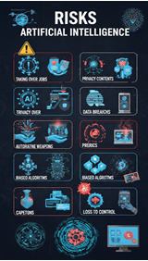  Risk of AI:  • Job Loss & Unemployment: Automation can replace human workers in many industries.  • Bias & Discrimination: AI systems can show unfair results if trained on biased data.  • Privacy Concerns: AI-powered surveillance and data collection can harm personal privacy. | • Security Threats: AI can be misused for cyber-attacks, hacking, and creating deep fakes.  • Lack of Human Control: Over-reliance on AI may lead to situations where humans lose decision-making power.  “Every technology has effects that depend on how it is used.” |   Future of AI:  • Smarter Automation: AI will handle more complex tasks in industries, reducing human effort and increasing efficiency.  • Human–AI Collaboration: Instead of replacing people, AI will increasingly work alongside humans to support better decisions.  • Ethical & Responsible AI: Future AI will focus on fairness, transparency, and safety to avoid risks like bias or misuse.  • Everyday Integration: AI will become more deeply integrated into daily life through healthcare, education, transportation, and personal devices.

